**World Quant University**

**Professor: Harry Wang**

**Algorithms II**

Nikolas Lippmann Pareschi - [nikolaslippmann@gmail.com](mailto:nikolaslippmann@gmail.com)

**Assignment 5: Simplex Algorithm**

**Problem 1:**

A company is investing in two securities, x1 and x2.  The risk management division of the company indicated the following constraints to the investment strategy:

* Short selling is not allowed
* The company must not buy more than 400 units of x1
* The total volume must not exceed 800 for every unit of x1 and x2 invested
* The total volume must not exceed 1,000 for every 2 units of x1 invested and 1 unit of x2 invested
* The total number of units is maximized considering that, for each 3 units of x1 security, 2 units of x2 security must be bought

The company requests the following from you:

1. Indicate the objective function.
2. Write the optimization problem.
3. Find x1 and x2 values that maximize the objective function and explain the algorithm.

* Use the pulp modeler for Python.

First we define our objective function which is to maximize x1 and x2.

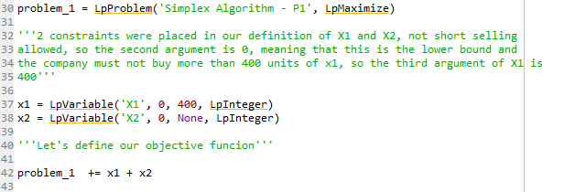

We also defined into X1 and X2 two constraints described above. One constrained is the fact that short selling is not allowed (x1 and x2 have a lower bound 0 – second argument of X1 and X2). The other constrained is the upper bound of 400 defined in X1.

We then define the 3 other constraints:

* The total volume must not exceed 800 for every unit of x1 and x2 invested
* The total volume must not exceed 1,000 for every 2 units of x1 invested and 1 unit of x2 invested
* The total number of units is maximized considering that, for each 3 units of x1 security, 2 units of x2 security must be bought

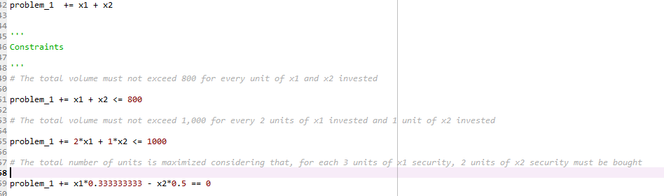

We then solve the linear problem using simplex with pulp:

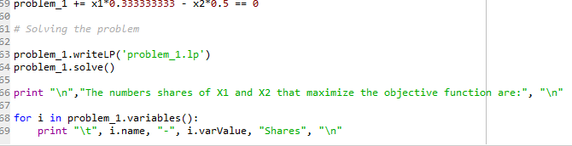

The results are:

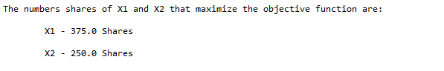

Which respect the constraints given. The pulp package run internally the simplex algorithm. Mathworld [1] has a nice and concise explanation of the simplex algorithm

The simplex method is a method for solving problems in [linear programming](http://mathworld.wolfram.com/LinearProgramming.html). This method, invented by George Dantzig in 1947, tests adjacent vertices of the feasible set (which is a [polytope](http://mathworld.wolfram.com/Polytope.html)) in sequence so that at each new vertex the objective function improves or is unchanged. The simplex method is very efficient in practice, generally taking 2m to 3m iterations at most (where m is the number of equality constraints), and converging in expected [polynomial time](http://mathworld.wolfram.com/PolynomialTime.html) for certain distributions of random inputs (Nocedal and Wright 1999, Forsgren 2002). However, its worst-case complexity is exponential, as can be demonstrated with carefully constructed examples (Klee and Minty 1972).

A different type of methods for [linear programming](http://mathworld.wolfram.com/LinearProgramming.html) problems are [interior point methods](http://mathworld.wolfram.com/InteriorPointMethod.html), whose complexity is polynomial for both average and worst case. These methods construct a sequence of strictly feasible points (i.e., lying in the interior of the [polytope](http://mathworld.wolfram.com/Polytope.html) but never on its boundary) that converges to the solution. Research on interior point methods was spurred by a paper from Karmarkar (1984). In practice, one of the best interior-point methods is the [predictor-corrector method](http://mathworld.wolfram.com/Predictor-CorrectorMethods.html) of Mehrotra (1992), which is competitive with the simplex method, particularly for large-scale problems.

Dantzig's simplex method should not be confused with the downhill simplex method (Spendley 1962, Nelder and Mead 1965, Press *et al.*1992). The latter method solves an unconstrained minimization problem in n dimensions by maintaining at each iteration n+1 points that define a simplex. At each iteration, this simplex is updated by applying certain transformations to it so that it "rolls downhill" until it finds a minimum.

Pictures taken from 2 helps understanding the polytope described in Math World:

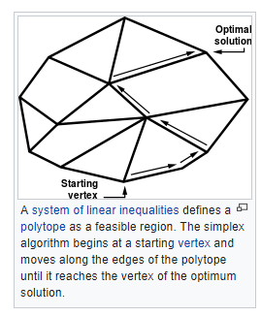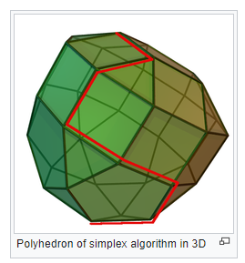

Regarding financial applications and alpha generation, linear problems can solve for example the necessity of hedge funds to maximize the capital invested without buying fractional lots, which have less liquidity. Also, we see some academic papers that used linear programming to alpha generation [3]:

***Abstract***

*This is a classic study, by the “Old Masters”, of the method-centered approach to management problems. It demonstrates once again the extraordinary power of the linear-programming framework, in dealing with complex business-decision problems. Students of the capital-budgeting process will find it filled with insights, and highly suggestive. It may eventually become the established basis for a revised conception of the interaction between financial planning and the economic analysis of engineering projects.*

[1] <http://mathworld.wolfram.com/SimplexMethod.html>

[2] <https://en.wikipedia.org/wiki/Simplex_algorithm>

[3] <https://www.tandfonline.com/doi/abs/10.1080/001379X6008546907?journalCode=utee20>